Azure Load Balancer and Application Gateway
In this lab, you configure two different Azure load balancing services to handle traffic for a public website:
- Azure Load Balancer (Layer 4)
Distributes incoming traffic evenly across multiple virtual machines.
- Azure Application Gateway (Layer 7)
Routes web traffic based on URL paths (for example, /image and /video) to different backend servers.
All resources are deployed in the same Azure region and same virtual network.

Architecture diagram - Application Gateway
Note: This Application Gateway is working in the same virtual network as the Load Balancer. This may not be typical in a production environment.
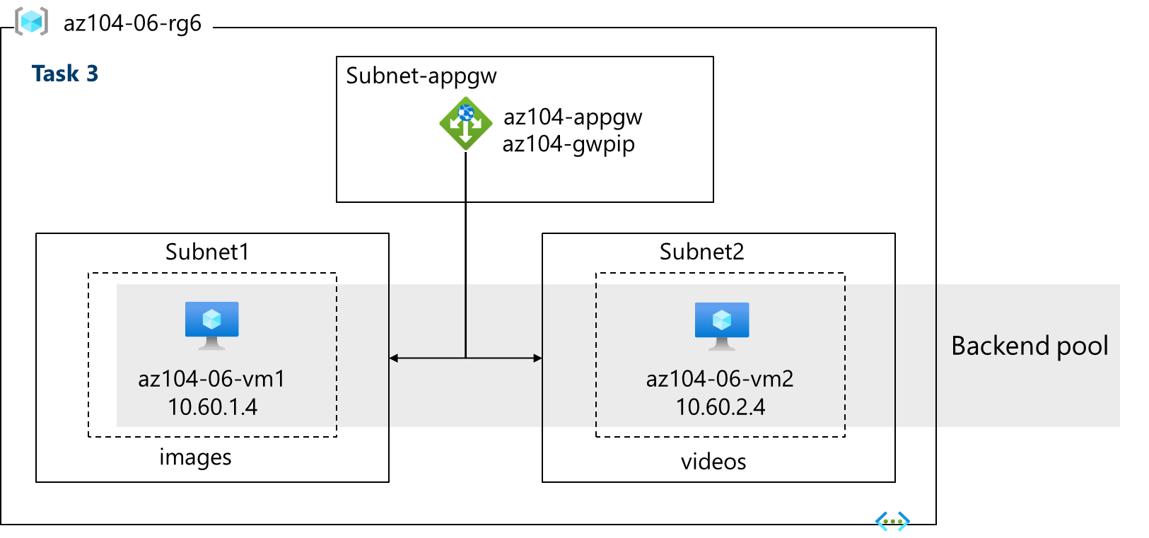

High-Level Architecture

1. Infrastructure
- One Virtual Network
- Three Subnets
- Three Virtual Machines
- One Network Security Group

2. Traffic Flow
- Load Balancer distributes traffic between two VMs.
- Application Gateway routes traffic based on URL paths:
  - /image/* → Image VM
  - /video/* → Video VM

Task 1: Infrastructure Deployment (Concepts)

ARM Template (Azure Resource Manager Template)
A JSON-based declarative file used to deploy Azure resources automatically.
Why used?
- Consistent deployments
- Faster provisioning
- Repeatable and error-free

Resource Group
A logical container that holds related Azure resources.
Benefits
- Easy cleanup
- Unified management
- Cost tracking

Task 2: Azure Load Balancer (Layer 4)

What is Azure Load Balancer?
Azure Load Balancer is a Layer 4 (TCP/UDP) load balancer that distributes network traffic based on IP address and port.
It does not inspect HTTP content.

OSI Layer
- Operates at Layer 4 (Transport layer)

Core Components of Azure Load Balancer

1. Frontend IP Configuration
The public IP address that receives incoming client traffic.
Example:
Client → Public IP → Load Balancer

2. Backend Pool
A group of virtual machines or NICs that receive traffic.
In this lab:
- VM0
- VM1

3. Load Balancing Rule
Defines how traffic flows from frontend to backend.
Key parameters:
- Protocol: TCP
- Frontend port: 80
- Backend port: 80
4. Health Probe
Checks whether backend VMs are healthy and reachable.
If a VM fails the probe:
- Traffic is stopped to that VM

5. Session Persistence
Determines whether a client stays connected to the same backend VM.
In this lab:
- None (round-robin behavior)

Why Use Azure Load Balancer?
Use cases
- High-performance traffic
- Non-HTTP workloads
- Simple web applications
- Low latency requirements
Limitations
- No URL-based routing
- No SSL termination
- No WAF

Task 3: Azure Application Gateway (Layer 7)

What is Azure Application Gateway?
Azure Application Gateway is a Layer 7 (HTTP/HTTPS) load balancer designed for web applications.
It understands:
- URLs
- Host headers
- Cookies
- HTTP methods

Why a Dedicated Subnet?
Application Gateway requires its own subnet because:
- It deploys managed instances
- It controls internal scaling and networking
Minimum size:
- /27 subnet

Core Components of Application Gateway

1. Frontend IP
Public IP address used to accept HTTP/HTTPS requests.

2. Listener
Defines how the gateway listens for traffic.
Listener includes:
- Protocol (HTTP/HTTPS)
- Port
- Frontend IP

3. Backend Pool
Contains the target VMs or IPs.
In this lab:
- Default pool (both VMs)
- Image pool (VM1)
- Video pool (VM2)

4. Backend Settings
Defines how traffic is sent to backend servers.
Includes:
- Port
- Protocol
- Cookie-based affinity
- Connection draining

5. Routing Rule
Defines how traffic is routed.
Two types:
- Basic routing
- Path-based routing (used in this lab)

6. Path-Based Routing
Routes traffic based on URL path.
Examples:
/image/* → Image VM
/video/* → Video VM
This is not possible with Azure Load Balancer.

Health Probes (Layer 7)
Application Gateway checks:
- HTTP response codes
- Application-level health
More intelligent than Load Balancer probes.

